High-Level Design
Project 3
Capture transaction data from SQS queue

Infrastructure Components:
- AWS SQS: Message queue service for receiving live transaction data from a third-party system.
- AWS Lambda: Serverless compute service for processing and handling the received messages.
- DynamoDB: NoSQL database for storing Account Master and Source System Master data.
Data Processing Flow Diagram:
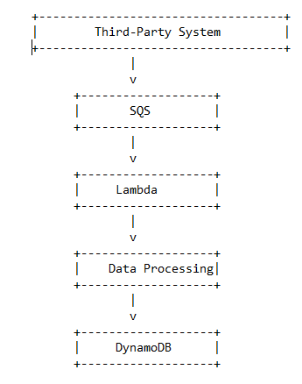

Detailed Workflow:
- Third-Party System Integration:
- The third-party system will post live transaction data to the SQS queue in JSON format.
- The SQS queue acts as a buffer, decoupling the transaction processing from the third-party system.
- Message Processing:
- AWS Lambda functions are triggered by messages from the SQS queue.
- The Lambda function retrieves the message from the queue.
- The JSON message is parsed to extract the relevant transaction details.
- Validations are performed on the transaction data.
- Transaction Creation:
- The Lambda function interacts with DynamoDB to fetch the necessary data from the Account Master and Source System Master tables.
- Based on the transaction details, three separate transactions are created for each incoming transaction.
- The transactions are recorded in the Ledger Transaction table in DynamoDB.
- Transaction Credit:
- The transactions are credited to the appropriate accounts based on the transaction type and amount.
- The "Product Sale" account, "Value Added Tax" account, and "Excise Duty" account are credited accordingly.
- Error Handling:
- If a transaction fails for any reason during processing or validation, it is flagged as an error.
- Failed transactions are recorded in a separate file for reload purposes.
- System Maintenance and Reporting:
- Regular maintenance tasks are performed to ensure the system's availability, performance, and data integrity.
- Reporting mechanisms can be implemented to generate transaction reports, monitor system performance, and track any errors or failures

Dataset Block Diagram:
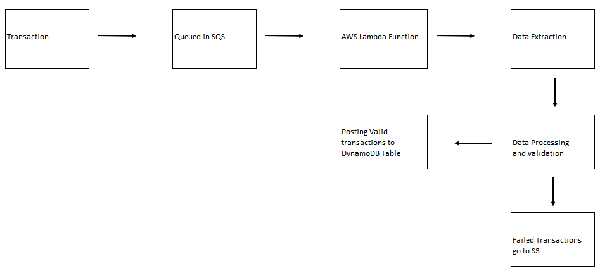

Data Models:
- Account Master Table:
- Stores information about various accounts, including account number, name, description, and type.
- Ledger Transaction Table:
- Stores details of each transaction, such as transaction ID, voucher code, transaction type, date, account number, amount, source system ID, and source system transaction ID.
- Source System Master Table:
- Contains information about different source systems, including system ID and system name.

Acceptance Criteria:
- For each incoming transaction, three separate transactions are created in the Ledger Transaction table.
- The transaction amounts are credited to the appropriate accounts, namely "Product Sale," "Value Added Tax," and "Excise Duty."
- In case of any transaction failure, a separate file of failed records is generated for reloading purposes.

The provided HLD is a high-level overview of the system design. It outlines the major components and their interactions.

